GRADE | 10 | SUBJECT |  | CAT |  | WEEK |  | W4  L4 |  | TOPIC | Solution Development: Word Processing –Tables(Design ,Tools Properties)
LESSON SUMMARY FOR:
DATE STARTED |  |  |  |  |  |  | DATE COMPLETED
LESSON OBJECTIVES |  |  | At the end of this lesson the learner must be able to:  - Know how to insert a table (Practical)  - Work with the Tools - Design and Layout of a table
TEACHER ACTIVITIES |  |  |  |  |  |  |  |  | LEARNER ACTIVITIES |  |  |  | TIMING | RESOURCES NEEDED
1. Methodology  - Classroom activity – Hands on  - Power point presentation  - Text book  2. Introduction  Introduce learners to:  Introduce learners to rows and columns  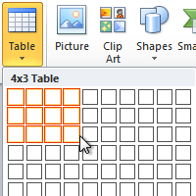  3. Main Body (Lesson presentation)  Insert a table  Tables give you a way to arrange content in rows and columns. This is a handy way to present information that is categorized or grouped, such as shirt sizes for your team, price and other criteria for items on a shopping list, or phone numbers and e-mail addresses for a list of contacts.  Click where you want to insert a table.  On the Insert tab, in the Tables group, click Table, and then drag to select the number of rows and columns that you want.  Insert Table  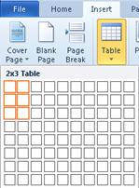  The Table tools will appear as you click into the table.  This will then give you two options :  Design :  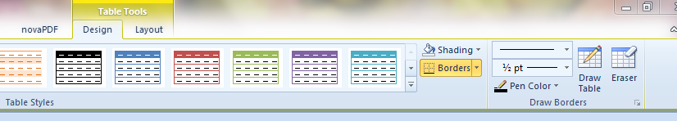  Layout :  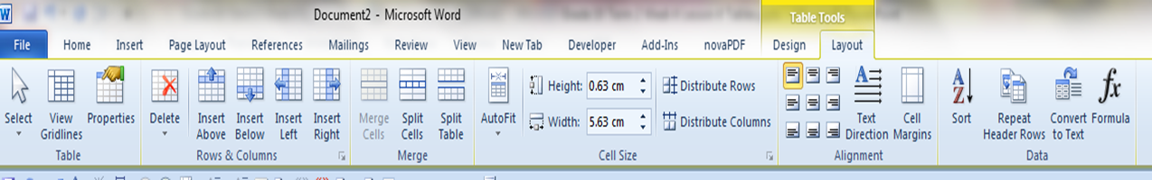  Open Table Properties  Once you’ve created a table, you can open the Table Properties dialog box by right-clicking anywhere in the table and choosing Table Properties.  Table Properties  Table Tab Default Settings  ƒ Size – Specifies the preferred width of the  Entire table. By default new tables fill up the  Page from the left to the right margin. (This  setting may be overridden by content and other  Property settings.)  ƒ Alignment – Positions the table relative to the  Margins of the page. This does NOT affect  Alignment of text within cells.  ƒ Text Wrapping – Can allow surrounding text to  Wrap around the table. (The Positioning button  will control position of the table relative to the  Text.)  ƒ Borders and Shading – Performs the same  function as the Borders and Shading command  In the Format menu.  Source:  http://www.gcflearnfree.org/word2010/21.2  www.mc.vanderbilt.edu/infocntr  4. Conclusion  Tables in Word can be frustrating when the learner is not sure how to control the settings of a table’s rows, columns, cells, and the table as a whole. Learners must practice inserting columns and also edit an existing table which is in lessons to follow. |  |  |  |  |  |  |  |  | Folder DataFiles_Solutions for learners to practice  Computers  Part of your Life  p. 234 Act 2  Via Afrika  p.139 Act 22  Focus  p.156 Act 6 |  |  |  | Introduction and definition 10 minutes  The rest of the time allocated on explanation of the lesson | PowerPoint presentation  Data projector  Prescribed Textbooks  Computers  Part of your Life  p. 232-235  Via Afrika  p.138-139  Focus  p. 154- 155

Name of Teacher: HOD:
Sign: Sign:
Date: _______________________________________ Date:

